Bahria University,

Karachi Campus

LAB EXPERIMENT NO.

**06**

LIST OF TASKS

|  |  |
| --- | --- |
| TASK NO | OBJECTIVE |
|  |  |
| 1 | Complete the table by solving the bitwise instruction of all Logical gates. Add the code and output of the logical gates to show solution of MASK BITS given in the table.   |  |  |  | | --- | --- | --- | | **Logic** | **Mask Bits** | | |  | **0** | **1** | | **AND** |  |  | | **OR** |  |  | | **NOT** |  |  | | **XOR** |  |  | | **XNOR** |  |  | | **NOR** |  |  | | **NAND** |  |  | |

Submitted On:

/11/2022

(Date: DD/MM/YY)

**TASK # 1** :Complete the table by solving the bitwise instruction of all Logical gates. Add the code and output of the logical gates to show solution of MASK BITS given in the table.

SOLUTION:

**AND OPERATION Mask with 0:**

.data

a: .asciiz "Enter the number :"

**OUTPUT:**



b:.asciiz "The Result is :"

.text

li $t0,0x00000000

la $a0,a

li $v0,4

syscall

li $v0,5

syscall

move $t1,$v0

and $t2,$t0,$t1

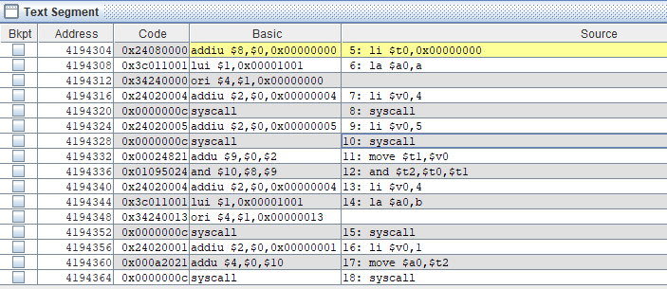

li $v0,4

la $a0,b

syscall

li $v0,1

move $a0,$t2

syscall

**AND OPERATION Mask with 1:**

.data

a: .asciiz "Enter the number :"

b:.asciiz "The Result is :"

.text

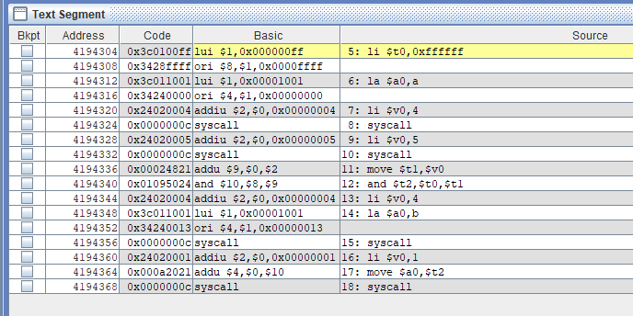

li $t0,0xffffff

la $a0,a

li $v0,4

syscall

li $v0,5

syscall

move $t1,$v0

and $t2,$t0,$t1

li $v0,4

la $a0,b

syscall

li $v0,1

move $a0,$t2

syscall

**OUTPUT**:

**OR OPERATION Mask with 0:**

.data

a: .asciiz "Enter the number :"

**OUTPUT:**



b:.asciiz "The Result is :"

.text

li $t0,0x00000000

la $a0,a

li $v0,4

syscall

li $v0,5

syscall

move $t1,$v0

or $t2,$t0,$t1

li $v0,4

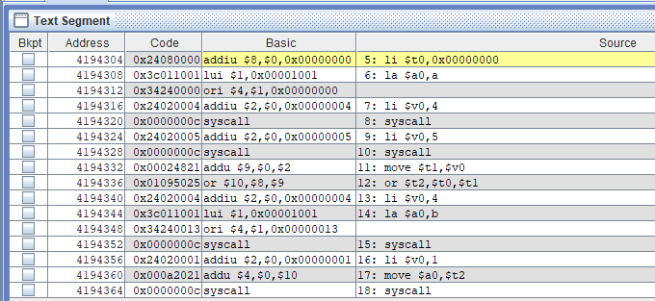

la $a0,b

syscall

li $v0,1

move $a0,$t2

syscall

**OR OPERATION Mask with 1:**

.data

a: .asciiz "Enter the number :"

b:.asciiz "The Result is :"

.text

li $t0,0xffffffff

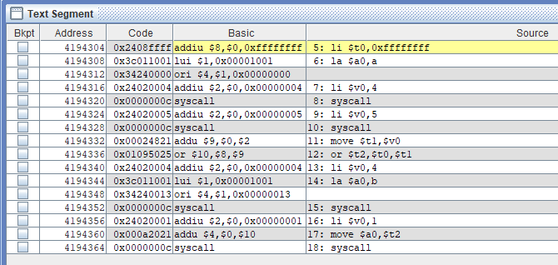

la $a0,a

li $v0,4

syscall

li $v0,5

syscall

move $t1,$v0

or $t2,$t0,$t1

li $v0,4

la $a0,b

syscall

li $v0,1

move $a0,$t2

syscall

**OUTPUT:**

**NOT OPERATION Mask with 0:**

.data

**OUTPUT:**

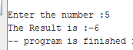

a: .asciiz "Enter the number :"

b:.asciiz "The Result is :"

.text

li $t0,0x00000000

la $a0,a

li $v0,4

syscall

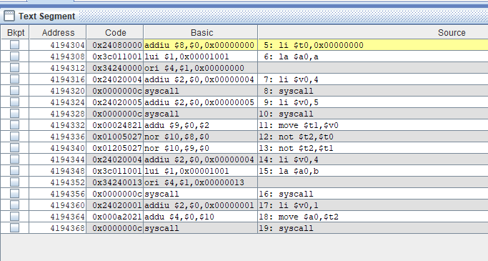

li $v0,5

syscall

move $t1,$v0

not $t2,$t0

not $t2,$t1

li $v0,4

la $a0,b

syscall

li $v0,1

move $a0,$t2

syscall

**NOT OPERATION Mask with 1:**

.data

a: .asciiz "Enter the number :"

**OUTPUT:**



b:.asciiz "The Result is :"

.text

li $t0,0xffffffff

la $a0,a

li $v0,4

syscall

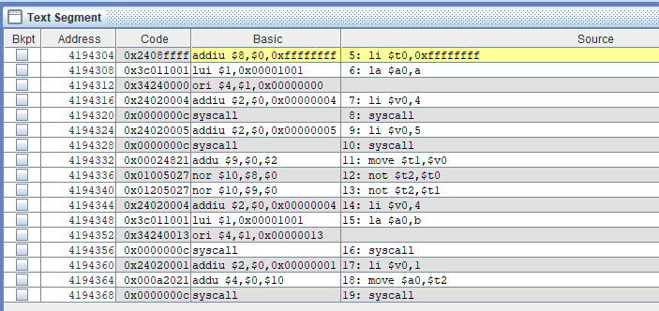

li $v0,5

syscall

move $t1,$v0

not $t2,$t0

li $v0,4

la $a0,b

syscall

li $v0,1

move $a0,$t2

syscall

**NOT OPERATION Mask with 0:**

.data

a: .asciiz "Enter the number :"

b:.asciiz "The Result is :"

**OUTPUT:**

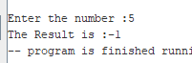

.text

li $t0,0x00000000

la $a0,a

li $v0,4

syscall

li $v0,5

syscall

move $t1,$v0

not $t2,$t0

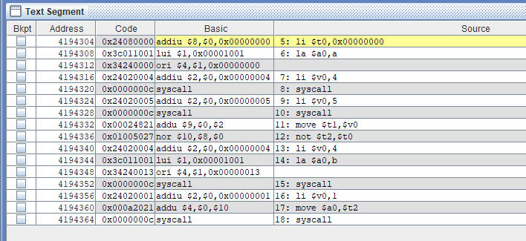

li $v0,4

la $a0,b

syscall

li $v0,1

move $a0,$t2

syscall

**XOR OPERATION Mask with 0:**

.data

**OUTPUT:**



a: .asciiz "Enter the number :"

b:.asciiz "The Result is :"

.text

li $t0,0x00000000

la $a0,a

li $v0,4

syscall

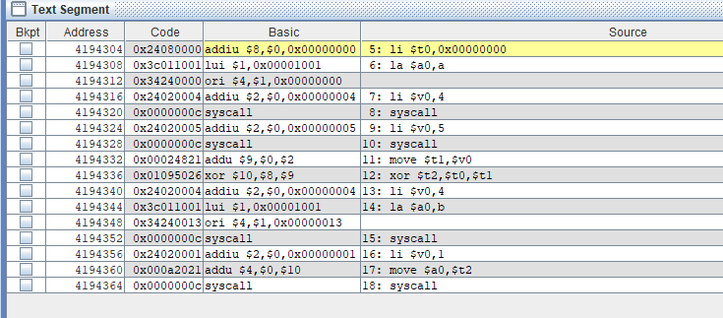

li $v0,5

syscall

move $t1,$v0

xor $t2,$t0,$t1

li $v0,4

la $a0,b

syscall

li $v0,1

move $a0,$t2

syscall

**XOR OPERATION Mask with 1:**

.data

a: .asciiz "Enter the number :"

**OUTPUT**:



b:.asciiz "The Result is :"

.text

li $t0,0xffffffff

la $a0,a

li $v0,4

syscall

li $v0,5

syscall

move $t1,$v0

xor $t2,$t0,$t1

li $v0,4

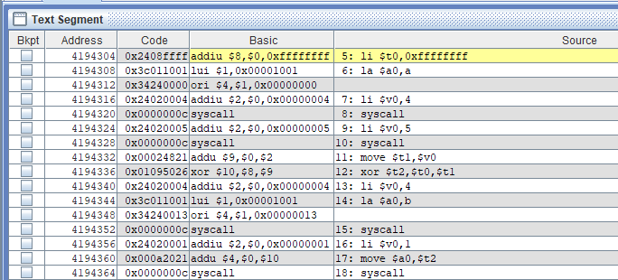

la $a0,b

syscall

li $v0,1

move $a0,$t2

syscall

**NOR OPERATION Mask with 0:**

.data

a: .asciiz "Enter the number :"

b:.asciiz "The Result is :"

**OUTPUT**:



.text

li $t0,0x00000000

la $a0,a

li $v0,4

syscall

li $v0,5

syscall

move $t1,$v0

nor $t2,$t0,$t1

li $v0,4

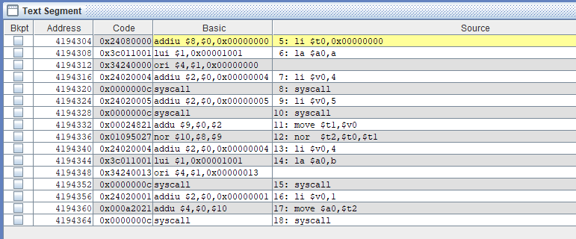

la $a0,b

syscall

li $v0,1

move $a0,$t2

syscall

**NOR OPERATION Mask with 1:**

.data

a: .asciiz "Enter the number :"

b:.asciiz "The Result is :"

.text

**OUTPUT**:



li $t0,0xffffffff

la $a0,a

li $v0,4

syscall

li $v0,5

syscall

move $t1,$v0

nor $t2,$t0,$t1

li $v0,4

la $a0,b

syscall

li $v0,1

move $a0,$t2

syscall

**XNOR OPERATION Mask with 0:**

.data

**OUTPUT**:



a: .asciiz "Enter the number :"

b:.asciiz "The Result is :"

.text

li $t0,0x00000000

la $a0,a

li $v0,4

syscall

li $v0,5

syscall

move $t1,$v0

or $t2,$t0,$t1

xor $t3,$t2,$t1

li $v0,4

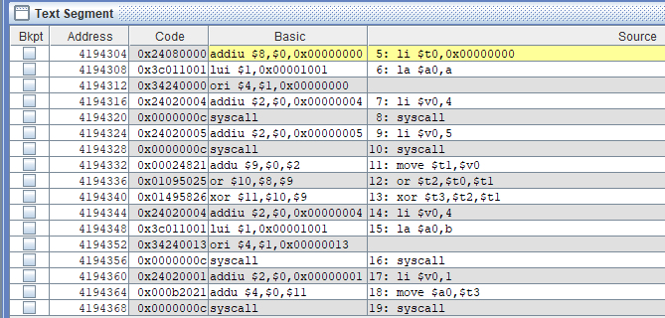

la $a0,b

syscall

li $v0,1

move $a0,$t3

syscall

**XNOR OPERATION Mask with 1:**

.data

a: .asciiz "Enter the number :"

b:.asciiz "The Result is :"

.text

**OUTPUT**:



li $t0,0xffffffff

la $a0,a

li $v0,4

syscall

li $v0,5

syscall

move $t1,$v0

or $t2,$t0,$t1

xor $t3,$t2,$t1

li $v0,4

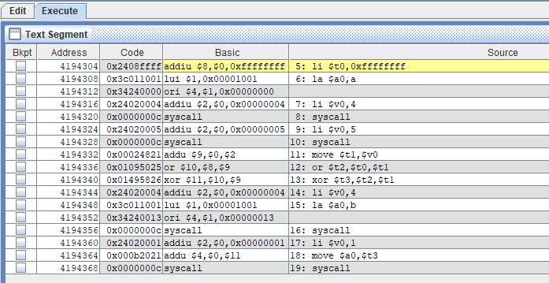

la $a0,b

syscall

li $v0,1

move $a0,$t3

syscall

**NAND OPERATION Mask with 0:**

.data

a: .asciiz "Enter the number :"

b:.asciiz "The Result is :"

**OUTPUT**:



.text

li $t0,0x00000000

la $a0,a

li $v0,4

syscall

li $v0,5

syscall

move $t1,$v0

and $t2,$t0,$t1

not $t3,$t2

li $v0,4

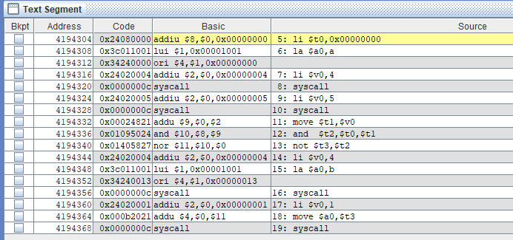

la $a0,b

syscall

li $v0,1

move $a0,$t3

syscall

**NAND OPERATION Mask with 1:**

.data

a: .asciiz "Enter the number :"

**OUTPUT**:



b:.asciiz "The Result is :"

.text

li $t0,0xffffffff

la $a0,a

li $v0,4

syscall

li $v0,5

syscall

move $t1,$v0

and $t2,$t0,$t1

not $t3,$t2

li $v0,4

la $a0,b

syscall

li $v0,1

move $a0,$t3

syscall

**TABLE SOLUTION**

|  |  |  |
| --- | --- | --- |
| **Logic** | **Mask Bits** | |
|  | **0** | **1** |
| **AND** | 0 | 5 |
| **OR** | 5 | -1 |
| **NOT** | -6 | 0 |
| **XOR** | 5 | -6 |
| **XNOR** | 0 | -6 |
| **NOR** | -6 | 0 |
| **NAND** | -1 | -6 |